CSE 5524 AU2025 Group Project Report

Group No.: 6
Group Members: 1. Kaivalya Pitale (pitale.4)
2. Karam Zeitouni (zeitouni.3)
Title: Automated Bot for YouTube Playable’s Gold Miner Tom
Introduction: YouTube Playables are games directly available to play on YouTube. In the project we will be developing a bot which will allow us to play Gold Miner Tom in an automated fashion. The bot will capture game screen data and analyze it using computer vision concepts. It will then also play the game while trying to win it with an optimum strategy.
Data source: Since the game is directly available on YouTube, we can live stream data of it. A screen recording of the game can also be maintained in case the game gets removed in the future. As we have live data captured from YouTube screen, we can very robustly test our code. This also saved us storage, as we didn’t need to capture and save multiple test cases for development and testing.
Methodology:
This project has two stages to make the final application robust. These stages are calibration stage and object detection stage. Each stage runs separately, and latter requires output generated by former for better object detection specifically on user’s device.
- Calibration stage:
Calibration stage involves acclimatizing application to user’s device layout. This stage is only required to be done once. After running calibration python script from terminal, user must complete 10 steps at least once. These steps results in generation of key output files which include background.png, target.png and game_calibration.json, which are later required for background subtraction, template matching and object detection respectively.
Below are the steps along with a brief description:
- Capture Game Screen (hook LEFT) : …
- Capture Game Screen (hook RIGHT):
To capture background.png for background subtraction, we need an empty game screen which is hard to get since user would have to clear an entire level which is a difficult task. Instead we takes two screenshots one when right screen is empty i.e. when hook is left side and one when left screen is empty i.e. when hook is on right side. Here user manually clears both sides turn by turn and clicks on capture button to take screenshots. This screenshots are of entire screen and since we don’t know crop data for getting game screen, we just save them for now as PNG.
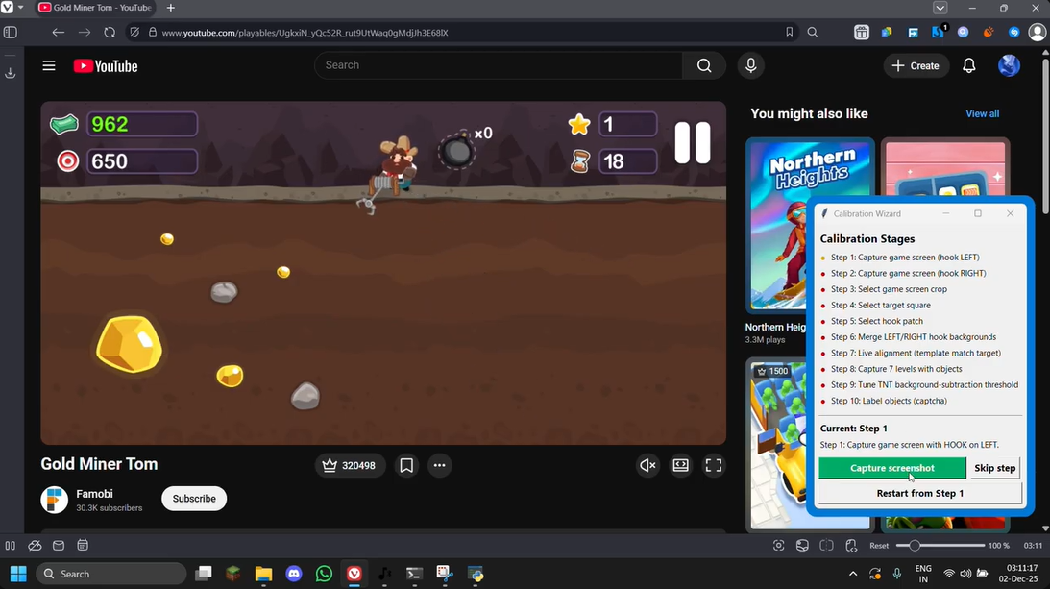 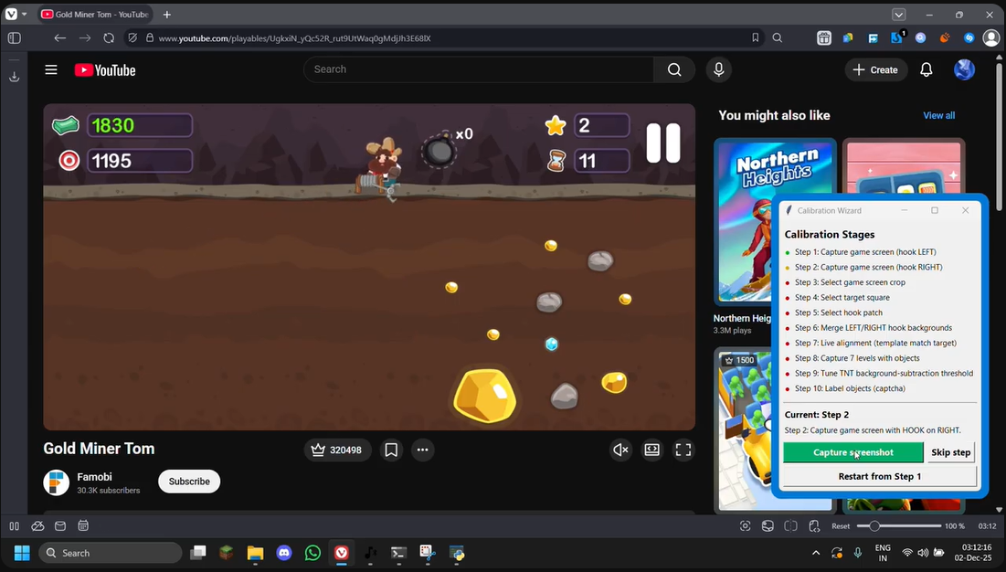
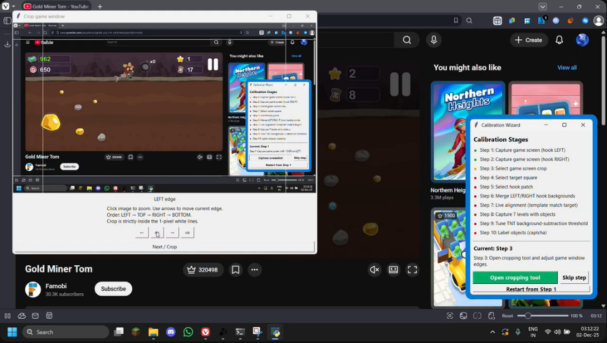
- Select game screen crop:
As it is obvious from last step, we need to detect game screen to start processing. This is done by locating the target symbol at top left using template matching and saving distance of edges from target. In this step we save game screen edge location manually and in the next step relative distance from target is computed to always find game screen crop reliably. This steps provides user with an UI which has arrow keys and live edge feedback to set edges.
- Select Target Square:
In this step we select target patch for template matching as it will be used to determine game screen. User is prompted with UI which has a cropping square which can be moved, and its size can be changed so as to perfectly crop out the target patch. It is in this step that we save target.png, along with its location and relative distances to the edges in calibration JSON file.
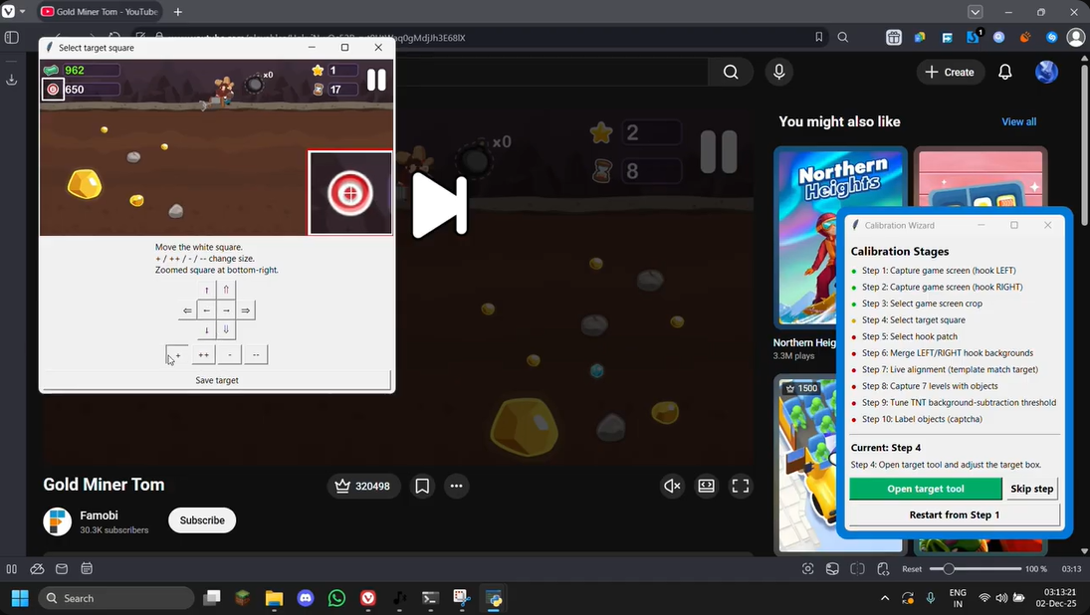
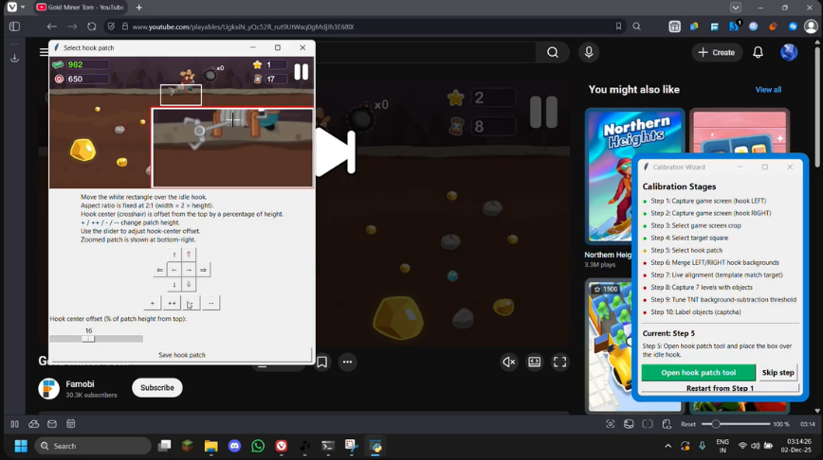
- Select hook patch:
In this step we select area in which the hook is swinging. User is provided with a rectangular patch which is ideal in this case, along with a variable hook center offset and patch size. It is in this step that we save hook center’s location relative to target and hook patch’s location relative to hook. This hook patch is later used for determining hook angle using background subtraction and centroid calculation.
- Merge LEFT/RIGHT hook backgrounds:
We previously didn’t knew how to detect and crop game screen but now since we have target template and half empty background screenshots, we can merge them to get out final background screenshot. First template matching is done over entire screenshot, after this using hook’s location and its distances from edges we determine game screen crop. This is done for both LEFT/RIGHT hook images. User is then provided with an UI which shows these two crops merged by a line which can be shifted to make sure it is centered.
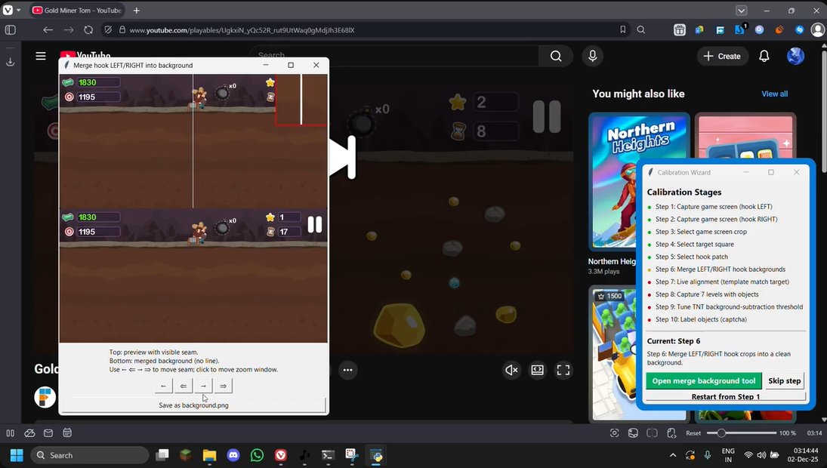
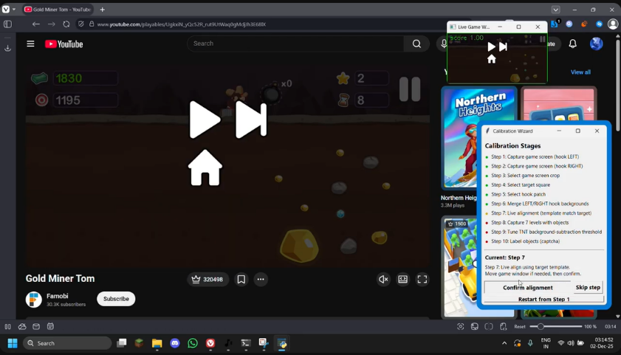
- Live alignment (template match target):
This is a test step where user is presented with a live detected game screen. This is to test if template matching and crop is working. In below image, live game screen capture can be seen at the top right corner.
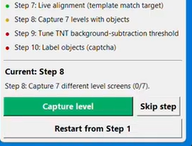
- Capture 7 levels with object:
These steps involve gathering different screenshots from variety of levels to get enough data to generate significant statistics on them. User is asked to capture 7 screenshots using capture button, progress is also shown in menu to keep track.
- Tune TNT-BG subtraction threshold:
We are detecting objects using background subtraction, this requires user to select a threshold which determines what difference is acceptable. This threshold is important as setting it too low can result in noise being detected and harder separability. While setting it too can result object splitting into multiple segments essentially detecting two or more incomplete objects. To prevent that in this step we do background subtraction on a single TNT item from game to determine optimal threshold. TNT is selected because it is most likely to split into segments due to high threshold.
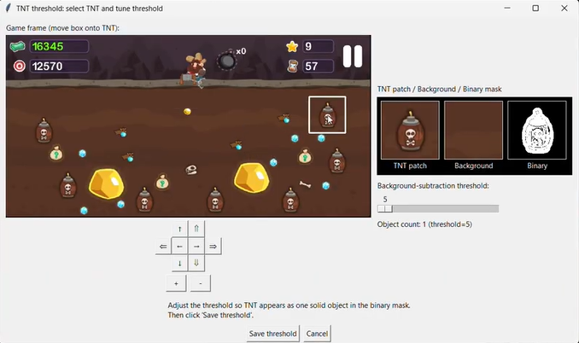
- Label objects:
Finally using the background, captured levels and selected threshold, background subtraction is done on all 7 images and candidate objects are selected for labelling. User is provided with a captcha style UI to select all objects which match a certain level. And simultaneously, remove any trash, noise or partially detected objects. Based on selected labels, in the end keys statistics for each of the labels is calculated which include avg_area, avg_r, avg_b, avg_g and average aspect ratio. Along with means, standard deviation is also calculated which will be used later to vary object detection/labelling threshold.
Once the final step is done, all of the above mentioned filed are saved along with required data needed during object detection. Calibration allows this application to run on multiple devices reliable and makes game screen detection robust (translation invariant).

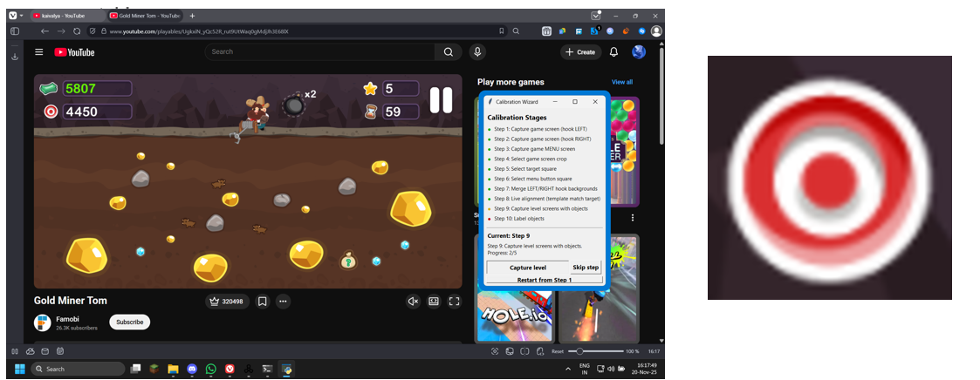
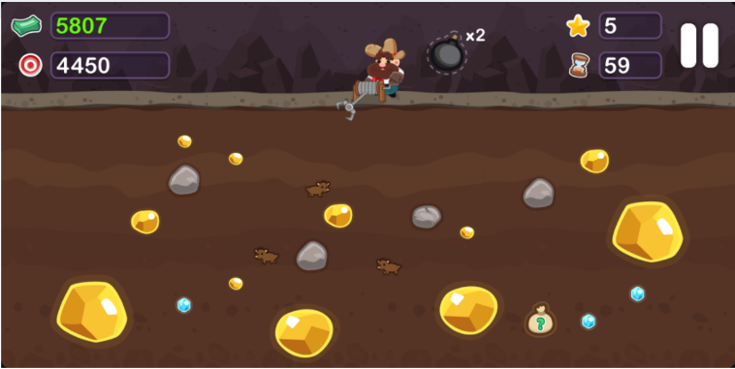
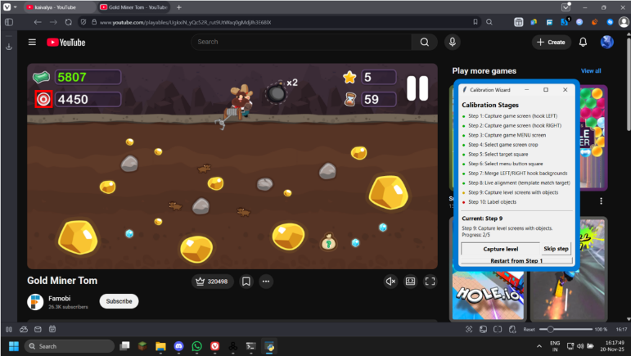
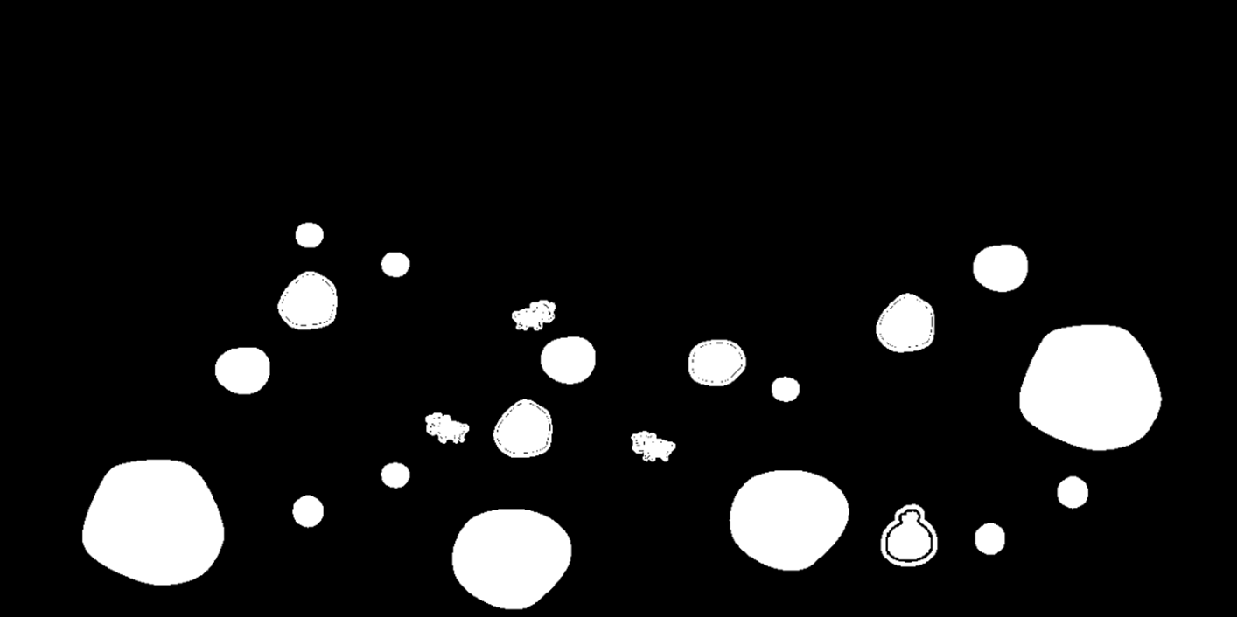
- Object Detection / Labelling stage:
Object detection stage’s goal is to detect all objects, determine which objects are unobstructed and if hook is aligned with the optimal choice. Below are the steps explaining how it is achieved:
1. Template matching using target.png:
In object detection raw input is screenshot of entire window. In this step we first find target template in the screenshot using template matching, once we find that, we use edge offsets from calibration file to get edge locations. Using these edge locations we can finally get game screen crop, ready to be processed.
2. Background subtraction:
Once we get our game crop, we then do background subtraction using saved background.png to get all item’s binary mask. Threshold for subtraction is taken from calibration file. We have also set a horizontal line here, only below which background subtraction takes place to prevent detecting junk and save computation.
3. Object detection and labelling:
Now that we have binary masks for all the objects we do statistical analysis on the actual patches against saved statistics in calibration file.
To classify one object using labe_stats (mean/std) we:
- Only consider labels in VALID_LABELS.
- For a label to be accepted, it must have at least 4/5 attributes
- with |z| <= max_sigma. Among those, pick label with minimum sum of z^2.
- Returns best_label or None.
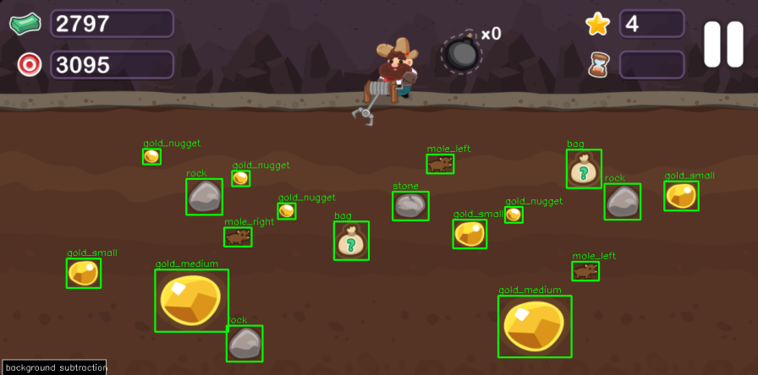

4. Object polar locations:
Since pixel coordinates operate in cartesian format and the game is naturally in polar format, it is hard to play it that way. Hence, we change all object locations to polar. Along with that we also calculate between what angle the object is subtended which is a useful information needed to determine obstruction.
5. Hook angle detection:
Using hook patch location saved from calibration file, we do background subtraction by finding that patch in game crop. This results in hook’s binary mask with which we find its centroid. Using centroid and hook’s center, we can find angle of the hook.
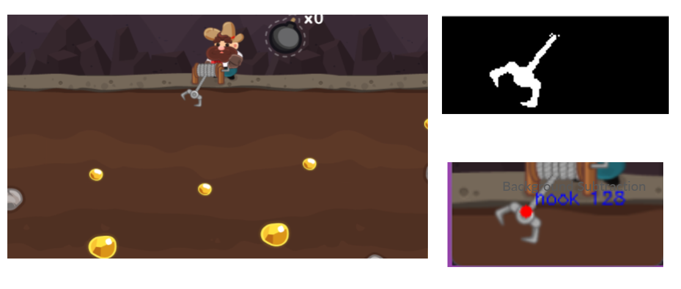
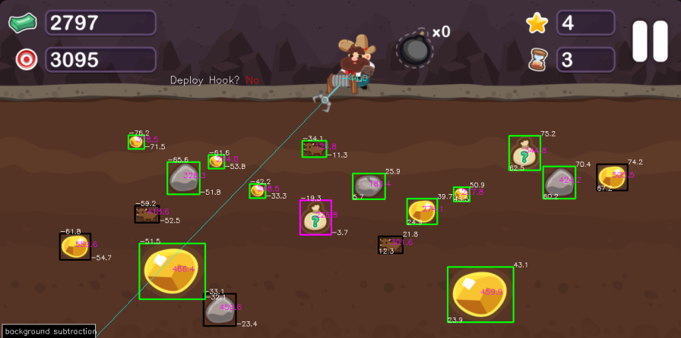
6. Naive Greedy algorithm and hook deployment decision:
Using polar coordinates data we determine which object are unobstructed, after this we find out which of those objects is the most expensive one depending on a saved priority list. If hook angle is same as the determined object’s polar angle, no other object is obstructing it, we set hook deployment status as “YES”. And “NO” when any of the above conditions are not met. User is also provided with an option to select a label in menu and then click on any of the detect objects on screen to get debug info on how many attributes it matches with selected label. A debug option for background subtraction and hook patch is also provided. Apart from this polar coordinate info i.e. angle and distance can also be shown on final image as per user’s need. And finally all the objects which are detected but not labelled are shown in red, these are either junk or mislabeled, all the objects which are detected but are obstructed are shown in black, while those which are unobstructed are shown in green, and the optimal item is shown with a pink border.

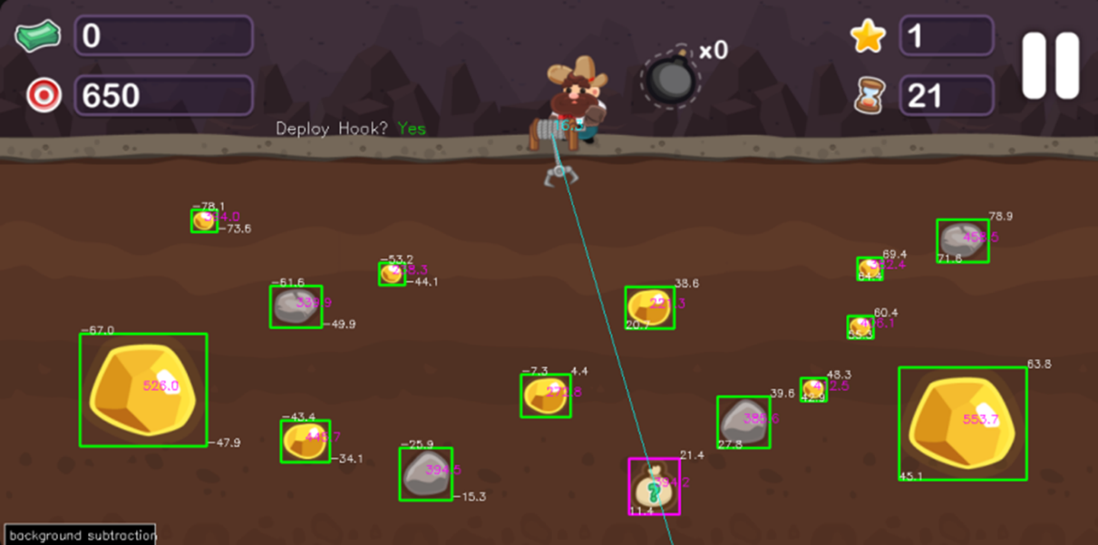
Implementation details:
Following modules are used for implementation
import os #$ Accessing folders/saving files
import glob #$ For quick finding recent images for a certain step
import json #$ Reading/Writing into JSON calibration file
import datetime #$ Generating date and time based timestamps while saving images
import threading #$ Running background threads like live alignment
import math #$ Calculations
import tkinter as tk #$ GUI
from tkinter import messagebox #$ Popups
import mss #$ Captuirng screenshots
import numpy as np
import cv2
from PIL import Image, ImageTk #$ For converting to GUI friendly image format
python calibration.txt for calibration
python object_det,txt for object detection and labelling
AI was used to fuse computer vision part coded by us into GUI elements
Result:
We were able to detect game screen, regardless of where it was on window. We successfully got all the objects from game screen and identified their labels. We were also able to determine obstructions and optimal objects to aim for next for maximum points with a naïve greedy algorithm. We weren’t able to set a macro for it to automatically play the game because of time constraint but that step would have been next.
Contributions:
Kaivalya Pitale
- Identifying game screen
- Calibration
- Identifying next best object and obstructions (naive greedy algorithm)
Karam Zeitouni
- Object detection using background subtraction
- Labeling using statistical analysis with calibrated values
- Hook angle detection

- We started early but end application was too ambitious
- Code is very inefficient at multiple places and low frame rate
- Initially plan was to detect object first and save a data file with all info,
and this file was later supposed to used by next teammate.
But this is too inefficient as we need data in local variable to have fast processing.
This made collaboration a bit difficult.
- Study more on python utility modules like mss, tkinter and macros
- Finish a complete sanity test first, then add features
- Better have decoupled modules to collaborate better
What went wrong ?? and Future Improvements !!

